AMERICAN CANCER SOCIETY
RELAY FOR LIFE – GRAND JUNCTION, COLORADO
JUNE 19 -20, 2009

TRACK MARKERS

The American Cancer Society will be holding the RELAY FOR LIFE, an overnight event, at the Canyon View Park on June 19 & 20, 2009. As part of this celebration, Track Markers for friends and supporters will be placed around the track for all to see during the relay. All sponsors will have a Track Marker.

Track Markers are small signs about 24 inches square on a wire frame (see picture). Each Track Marker bears the name of the supporter or loved one, in whose honor or memory the Track Marker was purchased. Track Markers are placed around the track prior to the start of the relay and remain there for the entire event.

You do not need to be an actual participant in the relay to purchase a Track Marker.

If you would like to purchase one or more Track Markers, clip and send in the form below. The sooner we stop this disease, the more lives we can save. All proceeds benefit the American Cancer Society. Thank you.

----------------------------------------------------------------------------------------------------------------------------------

GRAND JUNCTION TRACK MARKER ORDER FORM
A MINIMUM DONATION OF $100.00 IS REQUESTED FOR EACH TRACK MARKER

YOUR NAME: _____________________________________________________________________________

ADDRESS: _________________________________________________________________________________

PHONE: ___________________________AMOUNT ENCLOSED: $_____________DATE:_____________

WORDING TO BE PLACED ON TRACK MARKER(S): (Please limit to 8 words or less)

1. ________________________________________________________________________________

2. ________________________________________________________________________________

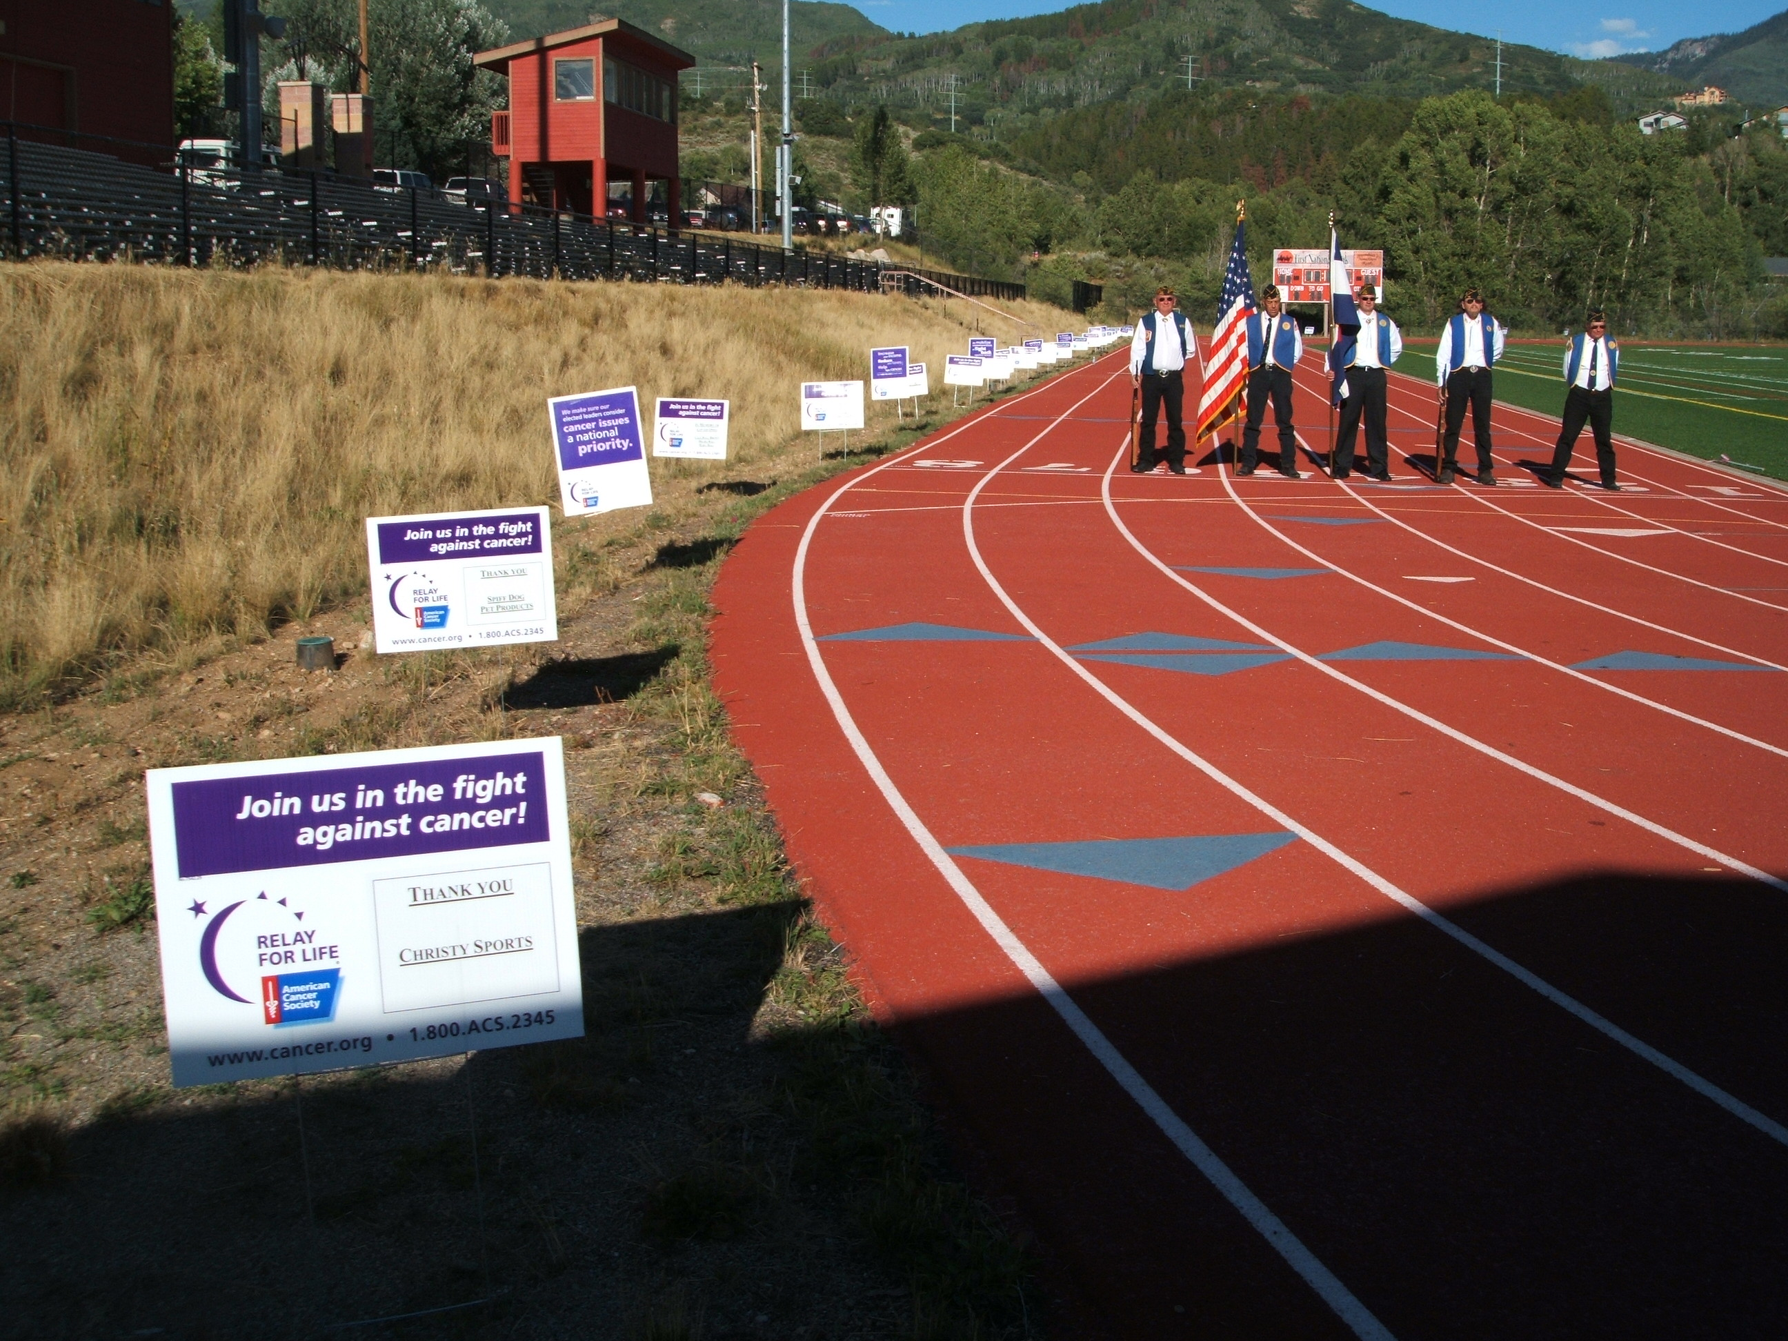 | Make checks payable to:  American Cancer Society  Please Send Forms and Contributions to:  Wynne Bouley  P.O. Box 546  Grand Junction, CO  (970) 216-0648  Wdoutdoors@bresnan.net  For questions, please call Mike at 970 254-5586  or email: mike.w.wood@cancer.org

SOLD BY:___________________________________________________(include Team and Members Name)

